**ISDS 552**

**Project on**

**Car Dealership (Sales)**

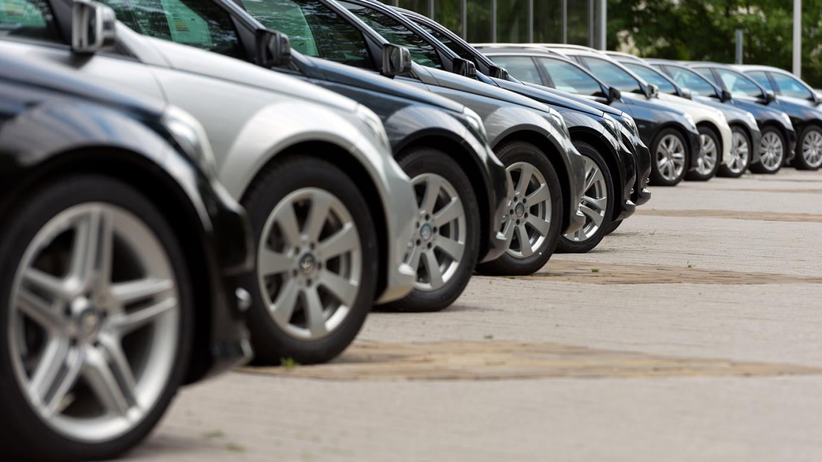

**By**

**Team- S3**

**Deepam Khirwar**

**Harshita Didwania**

**Kavindu Walimunige**

**Sanchit Singh**

**Sathiya Priya Jeevanandan**



**Sequence Diagram**

**Match Vehicles with Customer (On-Site)**

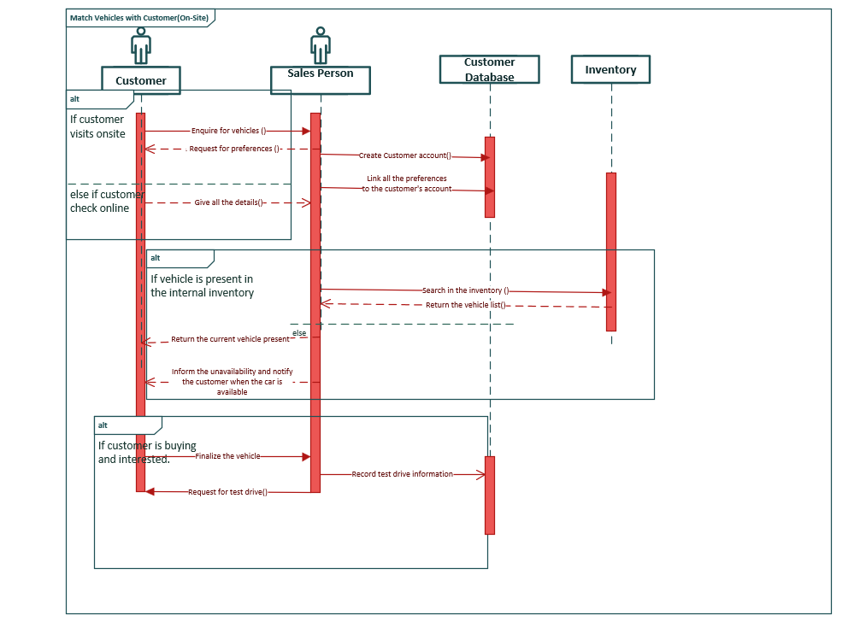

**Communication Diagram**

